Concept report

Contents

Introduction 2

The Stakeholders 2

Prior Knowledge and Market Survey 2

Design 3

Prototyping 4

Functional Specification 5

Technical Architecture 6

System Requirements and Technical Architecture 7

Purpose 7

Scope 7

System Overview 7

Ethical Audit 8

Evaluation plan 8

Project Management 9

Conclusion 9

Definitions 10

Bibliography 11

Appendices 12

Design (UML Diagrams) 12

Prototype (LFP research trial 3.pptx) 16

Project management (Project Libre) 17

Market Research Results (Collated data.xlsx) 18

Progress Log 23

# Introduction

The concept is an augmented reality app designed for runners; it is called pixelRun. Augmented reality is a type of technology that expands on the physical world by adding layers that contains digital information. With this technology, the group could add sounds, videos and graphics to the existing environment. It would be designed so that runners would be able to see coins on their running route, collecting these coins would give them points when collecting a predetermined amount, they would receive achievements trophies. The group would want to create this app to make the activity of running more interesting, it would be providing motivation for runners and non-runners.

# The Stakeholders

The stakeholders for the app are runners and non-runners from the ages 17-28, the focus group is 20-23. This age group has been created from extensive market research, as well as face-to-face interviews with stakeholders. Due to market research results, the direction of the app changed so the stakeholders were runners rather than gym-goers. The stakeholders were extended to those who did not run but wanted to, this was due to the results of the market research results. This app could be used as an introduction to running for beginners. The stakeholders would also have to be users who would be interested in AR or be willing to use that type of technology. In the market research, there was a realisation that older stakeholders were unwilling to use this app because those older did not like using any “difficult” technology and would just prefer to run. Younger stakeholders were more willing to use AR technology. The group completed 100 face-to-face interviews to narrow down the stakeholders to the designated age group. The reason the stakeholders have an interest in the concept is that the stakeholders find the AR concept of the app intriguing and believe that it would motivate them to run more and it was a unique concept that the stakeholders had not heard about before.

# Prior Knowledge and Market Survey

There are a few apps that use augmented reality, there currently is a large market for running apps and there are also apps that integrate augmented reality into a running ap. One of the apps that were considered being the main competitor was Pokémon GO 3, as this app has a similar structure to pixelRun. This game is extremely popular and has a large and loyal fanbase due to not only its history but the fact that it is a unique concept. Another app that has a similar concept to pixelRun is Zombie Run 4. This app is for runners, it creates adrenaline-inducing survival environments making it an interesting and unique app.

For Market Research, interviews were conducted as it is the best way to gather information. Between 90-100 people were interviewed to get a variety of different answers which will help when making the app. The interviews were conducted by splitting into groups and interviewing people from different areas in the university. After every batch of interviews, the questions of the interviews and the prototypes were changed after looking at the previous answers. The responses from the interviews changed the prototypes from what was supposed to be the “perfect” design. The interview answers were then made into tally charts which were converted to graphs, this was much easier to read and understand.

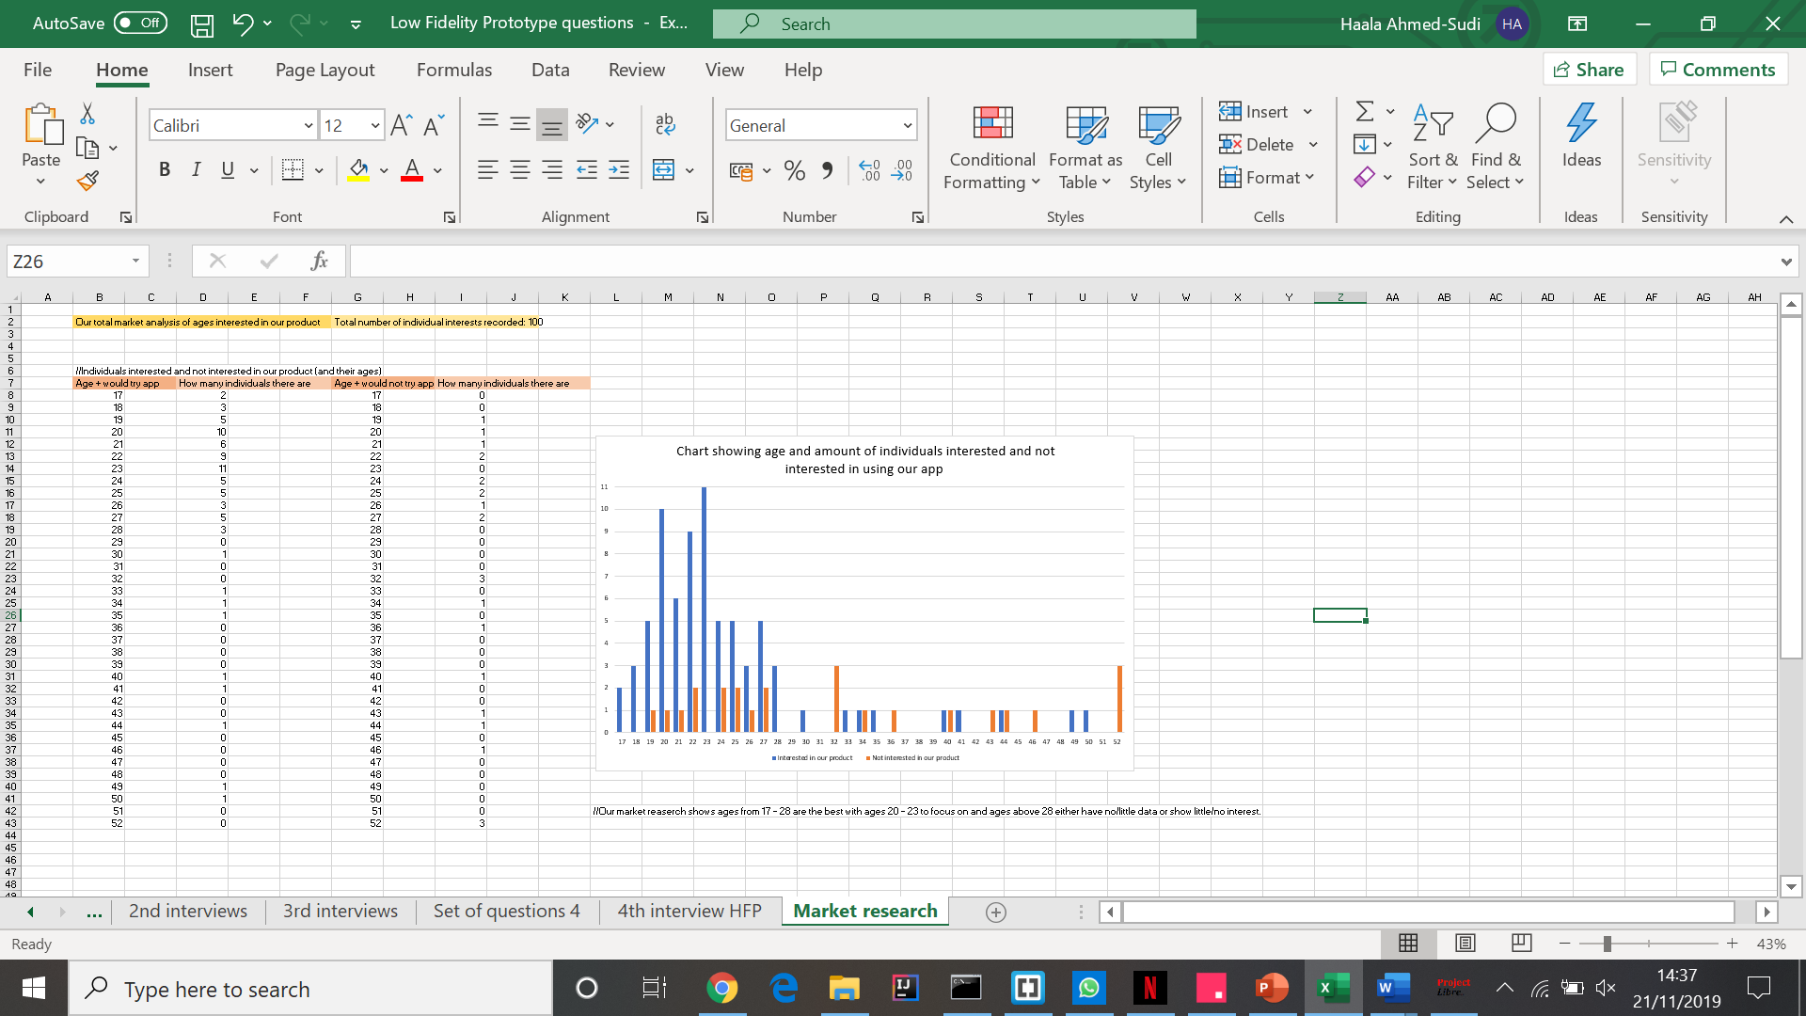Figure 1 5

# Design

Some of the stakeholders that will be targeted are marathon coordinators, tech support and the average users. The way these stakeholders use the app will be much different than the other stakeholders as it will depend on what they are using it for. For example, the UML for a marathon coordinator shows that they will use the app to make events for marathon runners whereas the average user will use it from time to time in a more relaxed way. The UML’s for the average users shows different types of people, older and younger users. For younger users they will look forward to using the features within the app and will want to adventure through all the software’s used, for example, they will want to use the AR feature. However, the older users will not use all the features, they will be more interested in just using the app as a running app. The UML diagram for tech support shows them fixing the problems that the users are having, they do not use any of the features in the app.

# Prototyping

The prototyping process began with the conduction of three trials of Low-fidelity prototypes. At each stage, the user recommendations, their preferences for the app layout, and features were recorded. Data about user ages (used to expand target market research) was also conducted. There was useful input and information about users not being interested in using glasses (users would prefer the phone camera (meaning that part of the design was cut out due to low interest)), that most users would be interested in physical collectable items, how to limit the number of pages (e.g. to not include an accessibility page as this is redundant), and other useful inputs changing the products structural design.

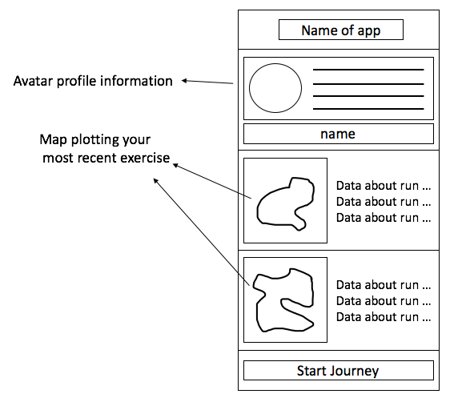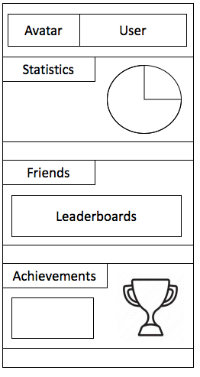

Figure 2 6 Figure 3 6

After completion, High-Fidelity prototype trial was conducted (which the product “inVision” was used for the designs; a 3D printed model was created for the “collectables” implementation. With this, user’s colour preferences on the app’s look, if the stakeholders liked the finished design, other useful features that could be implemented (e.g. forgetting password solution) were collected. Furthermore, more data about the target market was recorded. This concluded the prototype research (with 93 face-to-face interviews being conducted).

Lastly, the technical prototype aided in the decision of which technologies will be used, the outcome being: Java, Unity, Google maps/Mapbox Vision SDK, and MySQL.

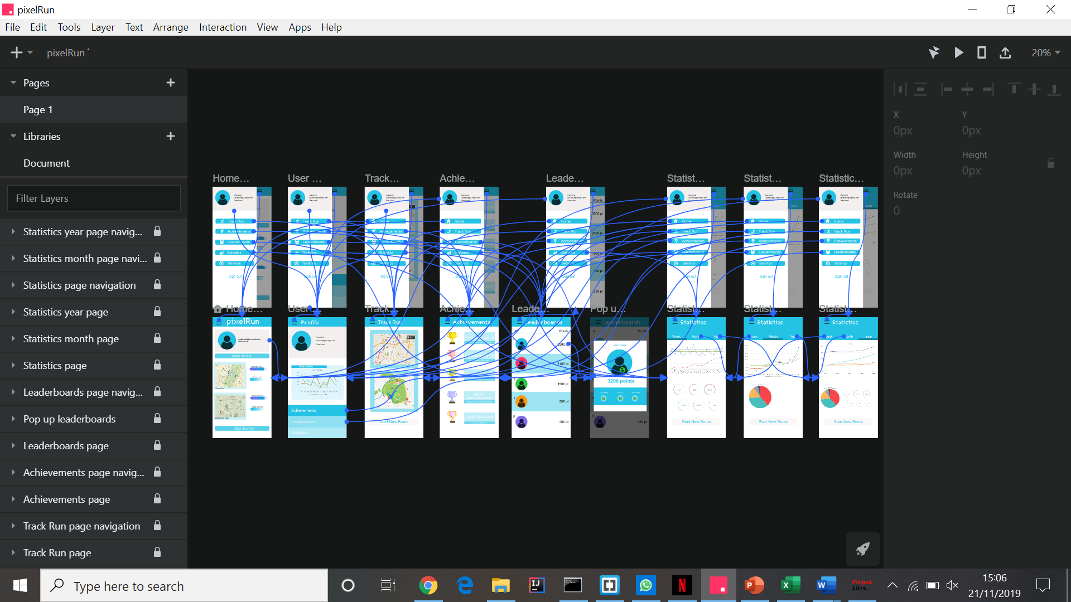

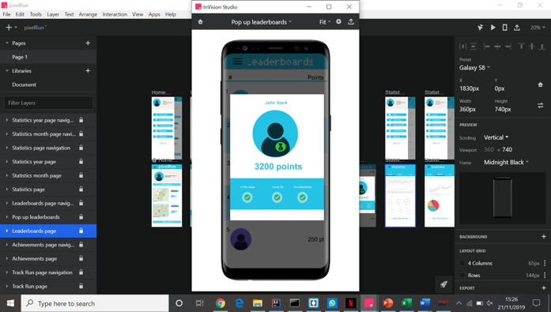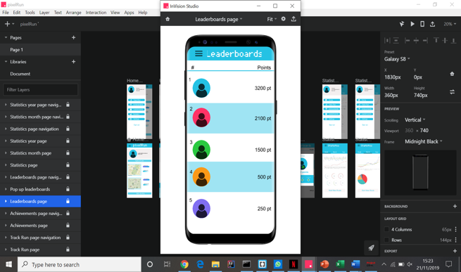Figure 4 7

Figure 5 7 Figure 6 7

# Functional Specification

The essential functional elements are composed of a database where key data needs to be stored and retrieved by the app so that user interaction is done properly. An example of this would be that security details can be accessed correctly so users are able to gain access to the main page from the login page or account details being shown in their profile instead of a blank page. Augmented reality so that digital models are displayed correctly through the smartphone's camera feed for the gaming aspect of the app to function. A Maps API to allow the user to set the route to travel on, also to view the designated checkpoints where the digital models can be collected using Augmented Reality. The use of the correct programming language that is compatible with the mobile platform the application is going to run on.

# Technical Architecture

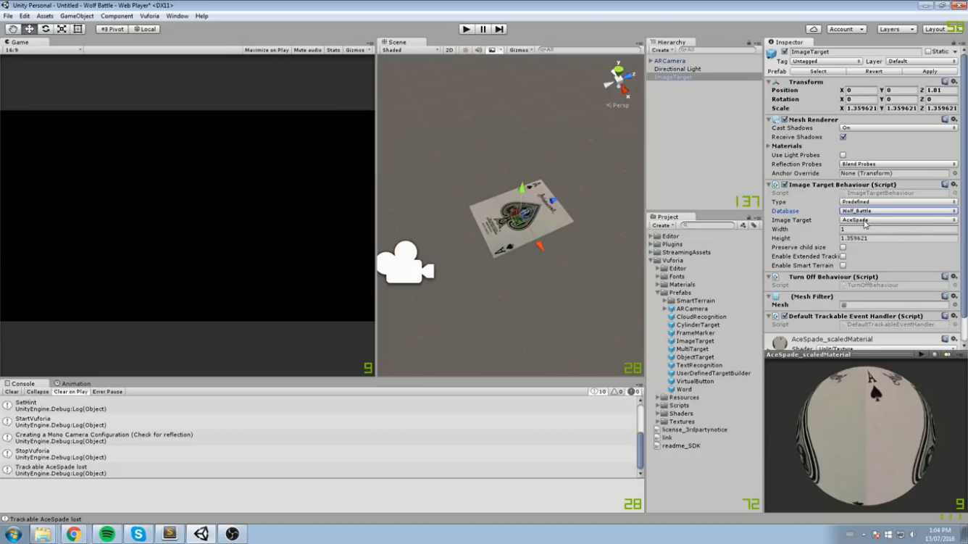For the technical architecture, some of the core technologies that are going to be implemented consist of the Java 9 programming language which is how the app is going to run on the android platform. This was chosen due to the fact Java is already currently being learnt, which would reduce the difficulty of the project since it already needs to be completed within a constricted time period and would result in not having to learn a new language such as Swift for IOS. MySQL 8, like the database management system of choice, the reasoning for this is the same Java as it is also currently being learnt. The use of Unity 13 over Unreal Engine 12 for Augmented reality, as Unity is compatible over a variety of platforms and much easier to learn/implement with more documentation and community support to help with troubleshooting whereas Unreal Engine is more geared to PC and console with a much higher skill curve to implement. At the moment Google Maps API 10 is going to incorporate into the project, however, MapBox API 11 is also an option due to an integrated Augmented reality feature being present within the street view feature, so it be could used without needing a 3rd party option however more research needs to be done whether custom digital models can be implemented into this feature.

Figure 7 (unity) 14

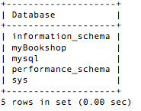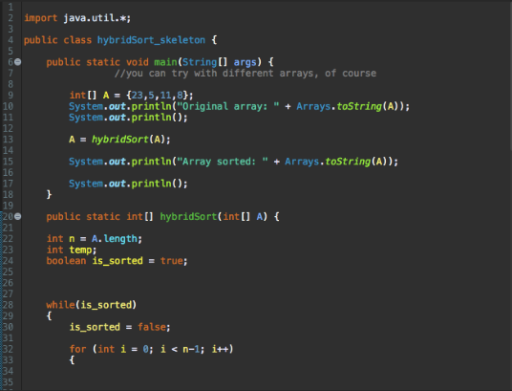

Figure 8 (MySQL) 15 Figure 9 (Java) 16

# System Requirements and Technical Architecture

## Purpose

The purpose of our app is to develop ‘game’ to motivate people to exercise outside and be active. (a ‘fun’ way to exercise, and something that can be a gateway into health). Our concept idea was influenced by browsing a variety of articles. The team had a common interest of exercise and sport and therefore, our concept revolved around this idea as after reading the article the group saw that one way to lose weight, is physical activity. This led to further articles such as one (also on Bupa.co.uk)1, 2 ‘expert reviewed’ by Dr Nagi Giumma Barakat a consultant Paediatrician/Neurologist.

## Scope

First-time users will need to navigate through the sign-up page. Whenever the user completes challenges available in the app, they are rewarded with in-app trophies, this will be the achievement page. The leader boards page is where users can compare their performance with other users to see how they rank. A statistics page which shows the data of all the activities the user has completed during the usage of the app so far. Finally, there will also be a settings page which enables each user to alter certain aspects of the app, with options to change the accessibility, display, account and display settings.

## System Overview

Java API:

Re-representing the technical architecture for our chosen product was that the group decided to use Java because of its popularity with most users in development and because it is used to create android apps. The group also thought about using OpenGL in Java because it has Augmented Reality capabilities because it allows you to program in java as well.

Database API:

The next API the group has chosen was databases because it is an electronic system that allows you to be able to manipulate data such that it can be accessed, manipulated and updated. The reason the group have chosen to add a database into our application is that it could be used to store the information regarding passwords and user accounts as well as the rewarding system.

Map API:

One of the technologies that are going to be implemented is the Google Maps API. The group is using this API as it is the most popular out of the few that there are. Google Maps is very easy to learn.

AR:

The group is also going to implement AR in our product. This feature will interact with the user’s smartphone camera. This is done by putting an overlay on top of the camera so that the user can see the coins in real life.

# Ethical Audit

For the app to successfully operate, personal details about users will be stored within a database. This includes password, full name, email etc. This is sensitive data and therefore it must be ensured that such data is kept private and unobtainable by other users. One potential issue concerns the safety of users. For instance, the coins that individuals must collect may generate in the middle of the road. Therefore, it is essential to ensure the coins are generated in a safe location. Minors are not involved in this project and market research was conducted on adults. However, everyone will have access to the app and will have the ability to use it. The app may not be suitable for everyone. For instance, people on wheelchairs may not be able to participate. In terms of security, it is imperative that users can only access their own accounts. Therefore, the app will include security features, such as a security question.

# Evaluation plan

Software testing will involve testing the basic functionality of the application to start with. For instance, each page of the application will be checked to ensure basic aspects of the app works (e.g. buttons) without the software crashing. The API functionality of the app will also be checked. Throughout the coding process, members of the group will review each other’s codes because another pair of eyes looking at the source code can uncover problems one member may fail to see. Code reviewing will take place throughout the programming phase of the project. After development acceptance testing will take place. This would involve ensuring that the product complies with the original purpose and checking to see if it meets the end user’s needs. To conduct the acceptance testing members of our target audience will have the opportunity to try the application in hopes of retrieving relevant feedback from potential customers before deployment.

# Project Management

“Project Libre” was used to manage the development process (a type of Gantt chart) with millstones and tasks being set (which needed to be completed). However, this process was taxing of time and was not beneficial for the team, as dates would be altered (milestone dates changed depending on time taking to complete). The idea of setting tasks to complete and working backwards from the goal (to find out which tasks need to be completed before starting new ones) was helpful and would be a feature used in the future.

An Excel document was used to record functions of the app, then dates and owners were assigned to these tasks. The project supervisor recommended this, and this could be a way to keep track of tasks being completed or need to be completed. Moreover, it would not be as time-consuming as using a Gantt chart.

Using Kanban programs (such as Trello) might be more useful, as it is not as time-consuming. This may be a potential tool for future use. Currently apps such as WhatsApp and Moodle (however, Moodle keeps having spamming errors, so it is not being used by the team), where the whole team communicates efficiently so tasks that need to be completed are easily coordinated. Lastly, the combination of Kanban logging and the creation of new milestones to be completed helped in productivity and finalisation of deadlines/work.

# Conclusion

In summary, the concept proposal that will be implemented is a fitness-focused augmented reality game that will motivate users to exercise and lead a healthier lifestyle. The concept proposal has evaluated testing the basic functionality of the application & reviewing the coding used to construct it. In the system requirements and technical architecture: the scope narrowed down the features of our application which made it clearer for the user and the system overview provided an insight into the systems needed to create an industry level product. The concept also considered the ethical considerations such as ensuring the user’s personal data is kept safe for them as well as ensuring that the coins in the game will not appear in dangerous areas. The project management was organised accordingly using WhatsApp and Project Libre. Trello was also a good way of organising the messages, this will be used in the future for the concept proposal. As it was tested by the team members and they found that it was good to use. Overall group 10 has detailed the functions needed for the app, creating low-fidelity and high-fidelity prototypes to be examined by their stakeholders, then presenting the technical architecture of the prototypes in depth. The group has an abundance of market research from 100 stakeholders, adapting their app for their target demographic.

# Definitions

AR (Augmented reality) - This is the interaction of computer-generated models with a real-world environment.

Unreal Engine, Unity – These are 3 dimensional (3D) developmental platforms (used for creating models that can be integrated with code).

Java – a programming language, used to create algorithms (clear steps leading to a solution) which a computer can execute (follow).

API (Application Programming Interface) – it is a set of already defined which allow and simplify the implementation of the software.

MySQL – a database management system.

# Bibliography

Bupa.co.uk. (2019). *Obesity in adults | Health Information | Bupa UK*. [online] Available at: https://www.bupa.co.uk/health-information/nutrition-diet/obesity-in-adults [Accessed 18 Oct. 2019].

2 Bupa.co.uk. (2019). *Obesity in children | Health Information | Bupa UK*. [online] Available at: https://www.bupa.co.uk/health-information/childrens-health/obesity-children [Accessed 18 Oct. 2019].

3 Pokemongo.com. (2019) *Pokémon Go.* [online] Available at: https://www.pokemongo.com/en-gb/ [Accessed 30 Nov].

4 Zombiesrungame.com (2019) *Zombies, Run.* [online] Available at: https://zombiesrungame.com/ [Accessed 30 Nov].

5 Figure 1, Collated data.xlsx. Available at: Appendices [Accessed 12 Dec. 2019]

6 Figure 2 & 3, LFP research trial 3.pptx. Available at: Appendices [Accessed 12 Dec. 2019]

7 Figure 4 & 5 & 6, inVision studio (high fidelity). Available at: link sent to our supervisor [Accessed 12 Dec. 2019]

8 Mysql.com. (2019). *MySQL*. [online] Available at: https://www.mysql.com/ [Accessed 30 Nov. 2019].

9 Java.com. (2019). *Java | Oracle*. [online] Available at: https://www.java.com/en/ [Accessed 30 Nov. 2019].

10 Cloud.google.com/maps-platform/ (2019). *Google Maps*. [online] Available at: https://cloud.google.com/maps-platform/ [Accessed 30 Nov. 2019].

11 Mapbox.com. (2019). *Mapbox*. [online] Available at: https://www.mapbox.com/ [Accessed 30 Nov. 2019].

12 Unrealengine.com. (2019). *Unreal Engine | What is Unreal Engine 4*. [online] Available at: https://www.unrealengine.com/en-US/what-is-unreal-engine-4 [Accessed 30 Nov. 2019].

13 Technologies, U. (2019). *Unity - Unity*. [online] Unity. Available at: https://unity.com/ [Accessed 30 Nov. 2019].

14 Figure 7, Unity application. Available at: <https://www.youtube.com/watch?v=mjNAPCFaZ9Y>/ [Accessed 12 Dec. 2019]

15 Figure 8, IS52027D: Data, and the Web. Available at: Appendices [Accessed 12 Dec. 2019]

16 Figure 9, IS52038B: Algorithms and Data Structure. Available at: Appendices [Accessed 12 Dec. 2019]

# Appendices

## Design (UML Diagrams)

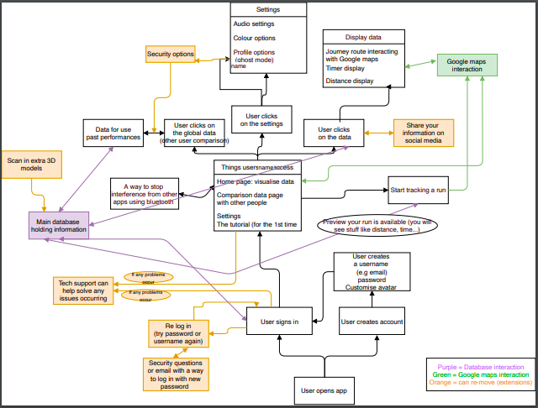Activity Diagram

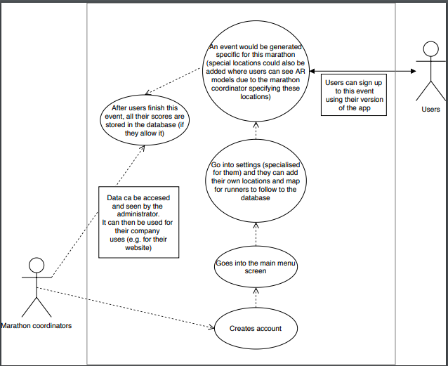UML - Marathon coordinator

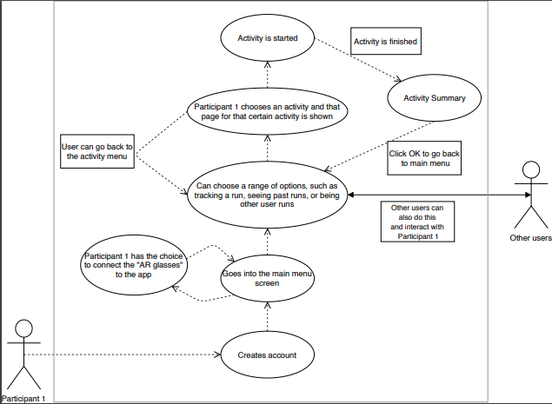UML - Participant 1

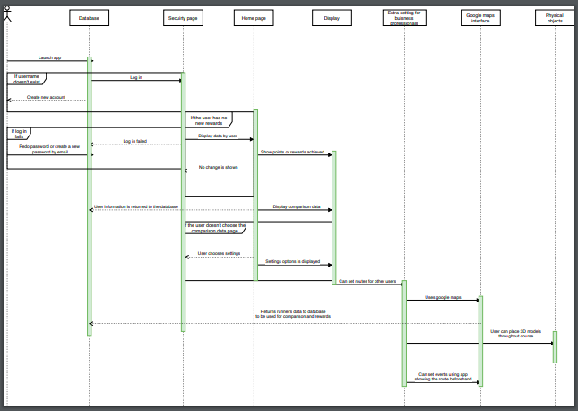Sequence Diagram

## Prototype (LFP research trial 3.pptx)

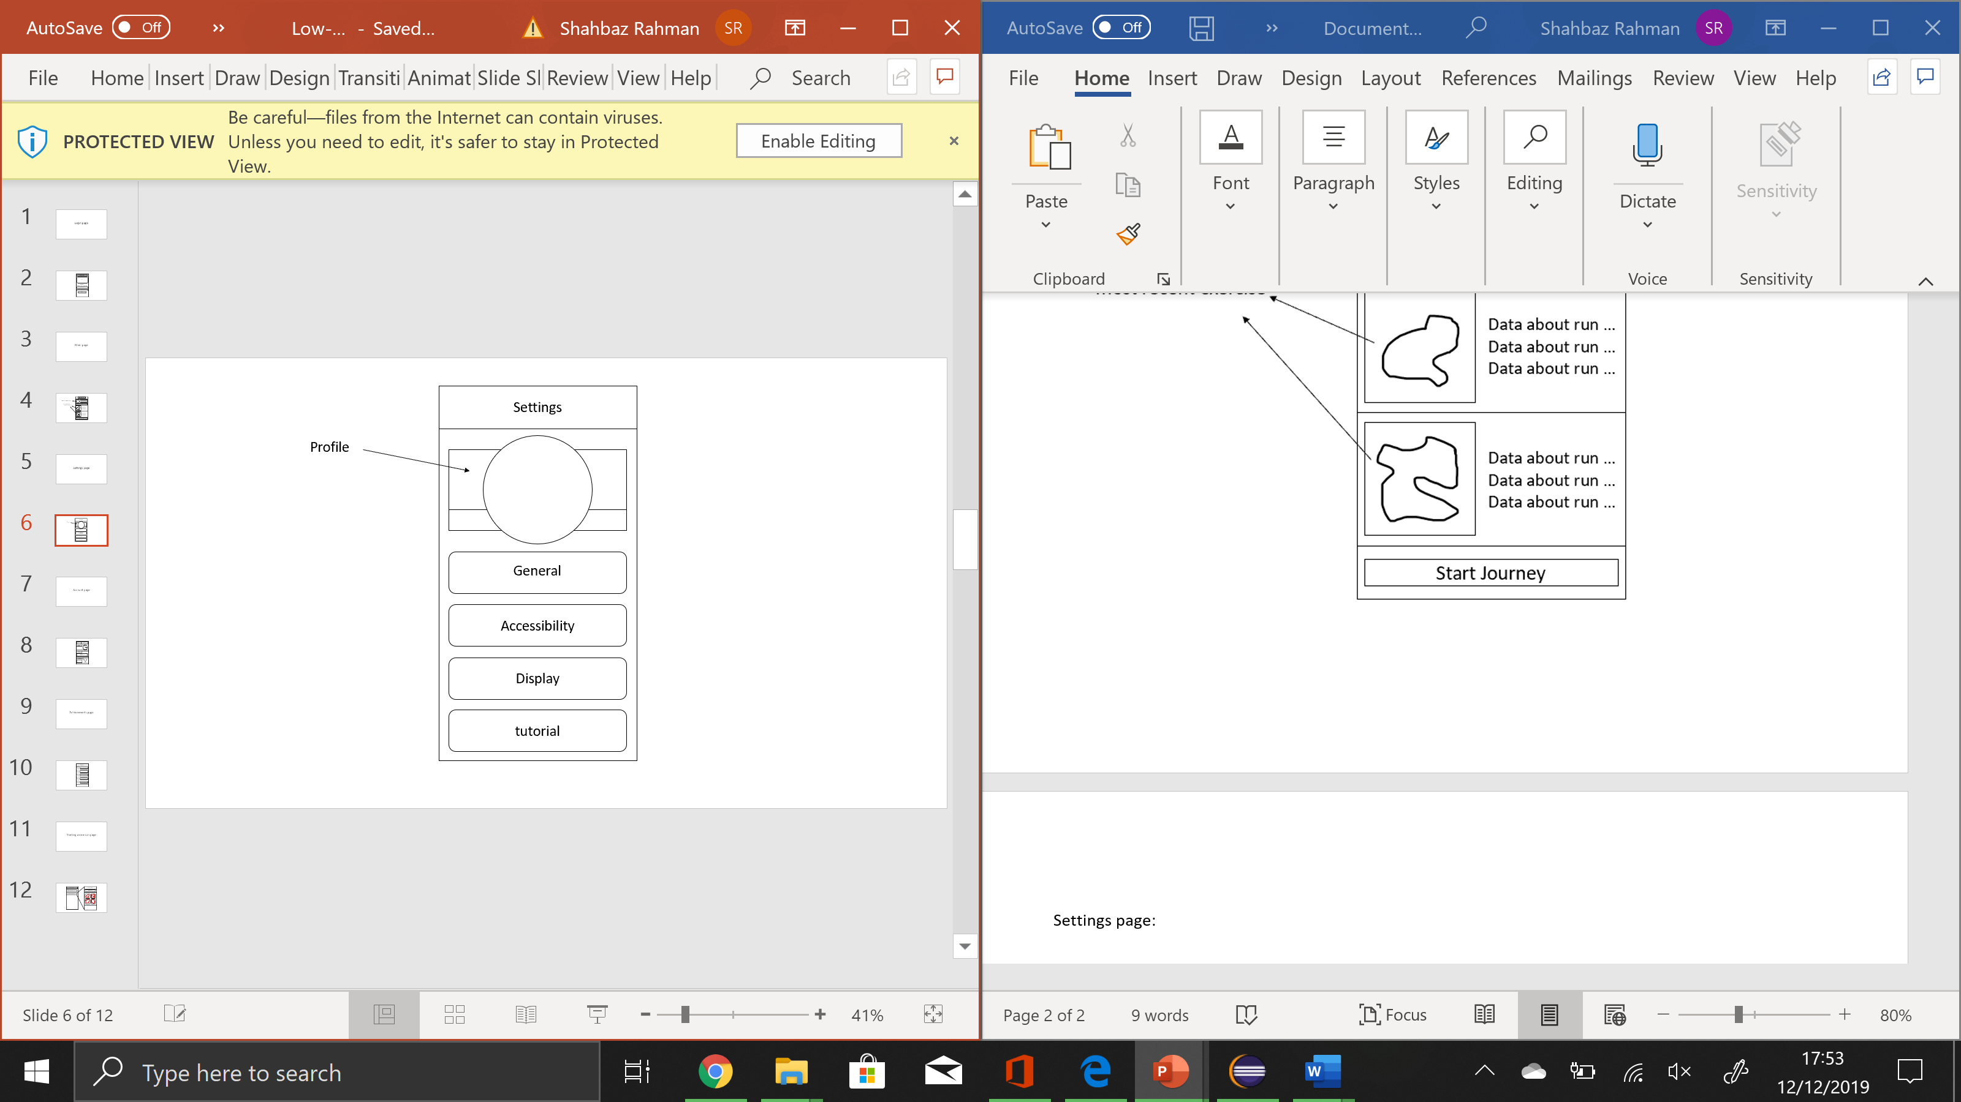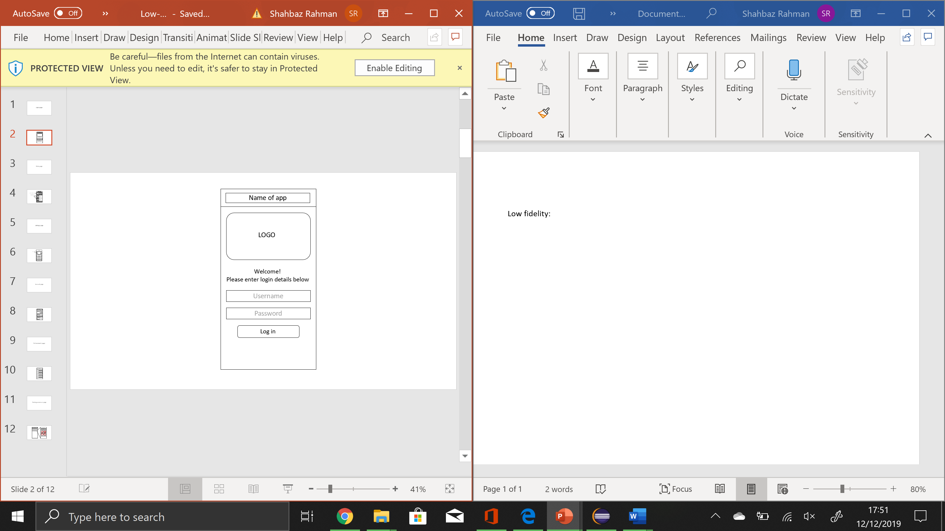 Log in page: Settings page:

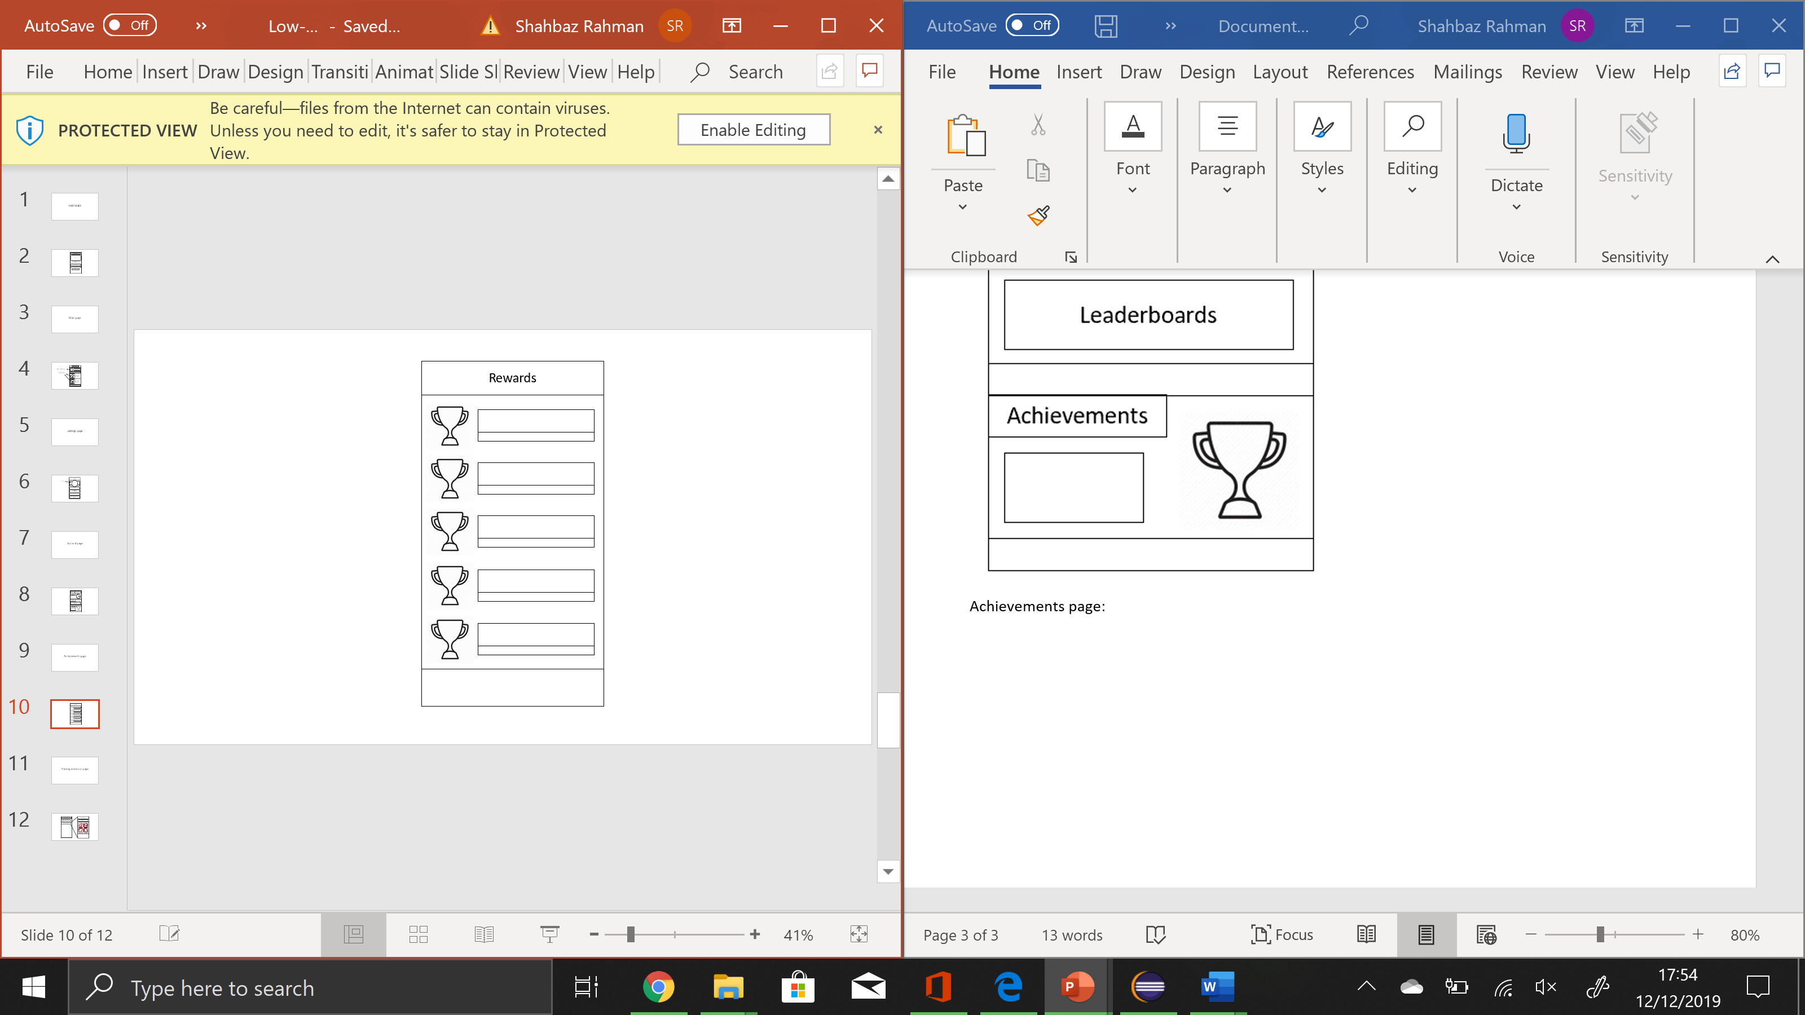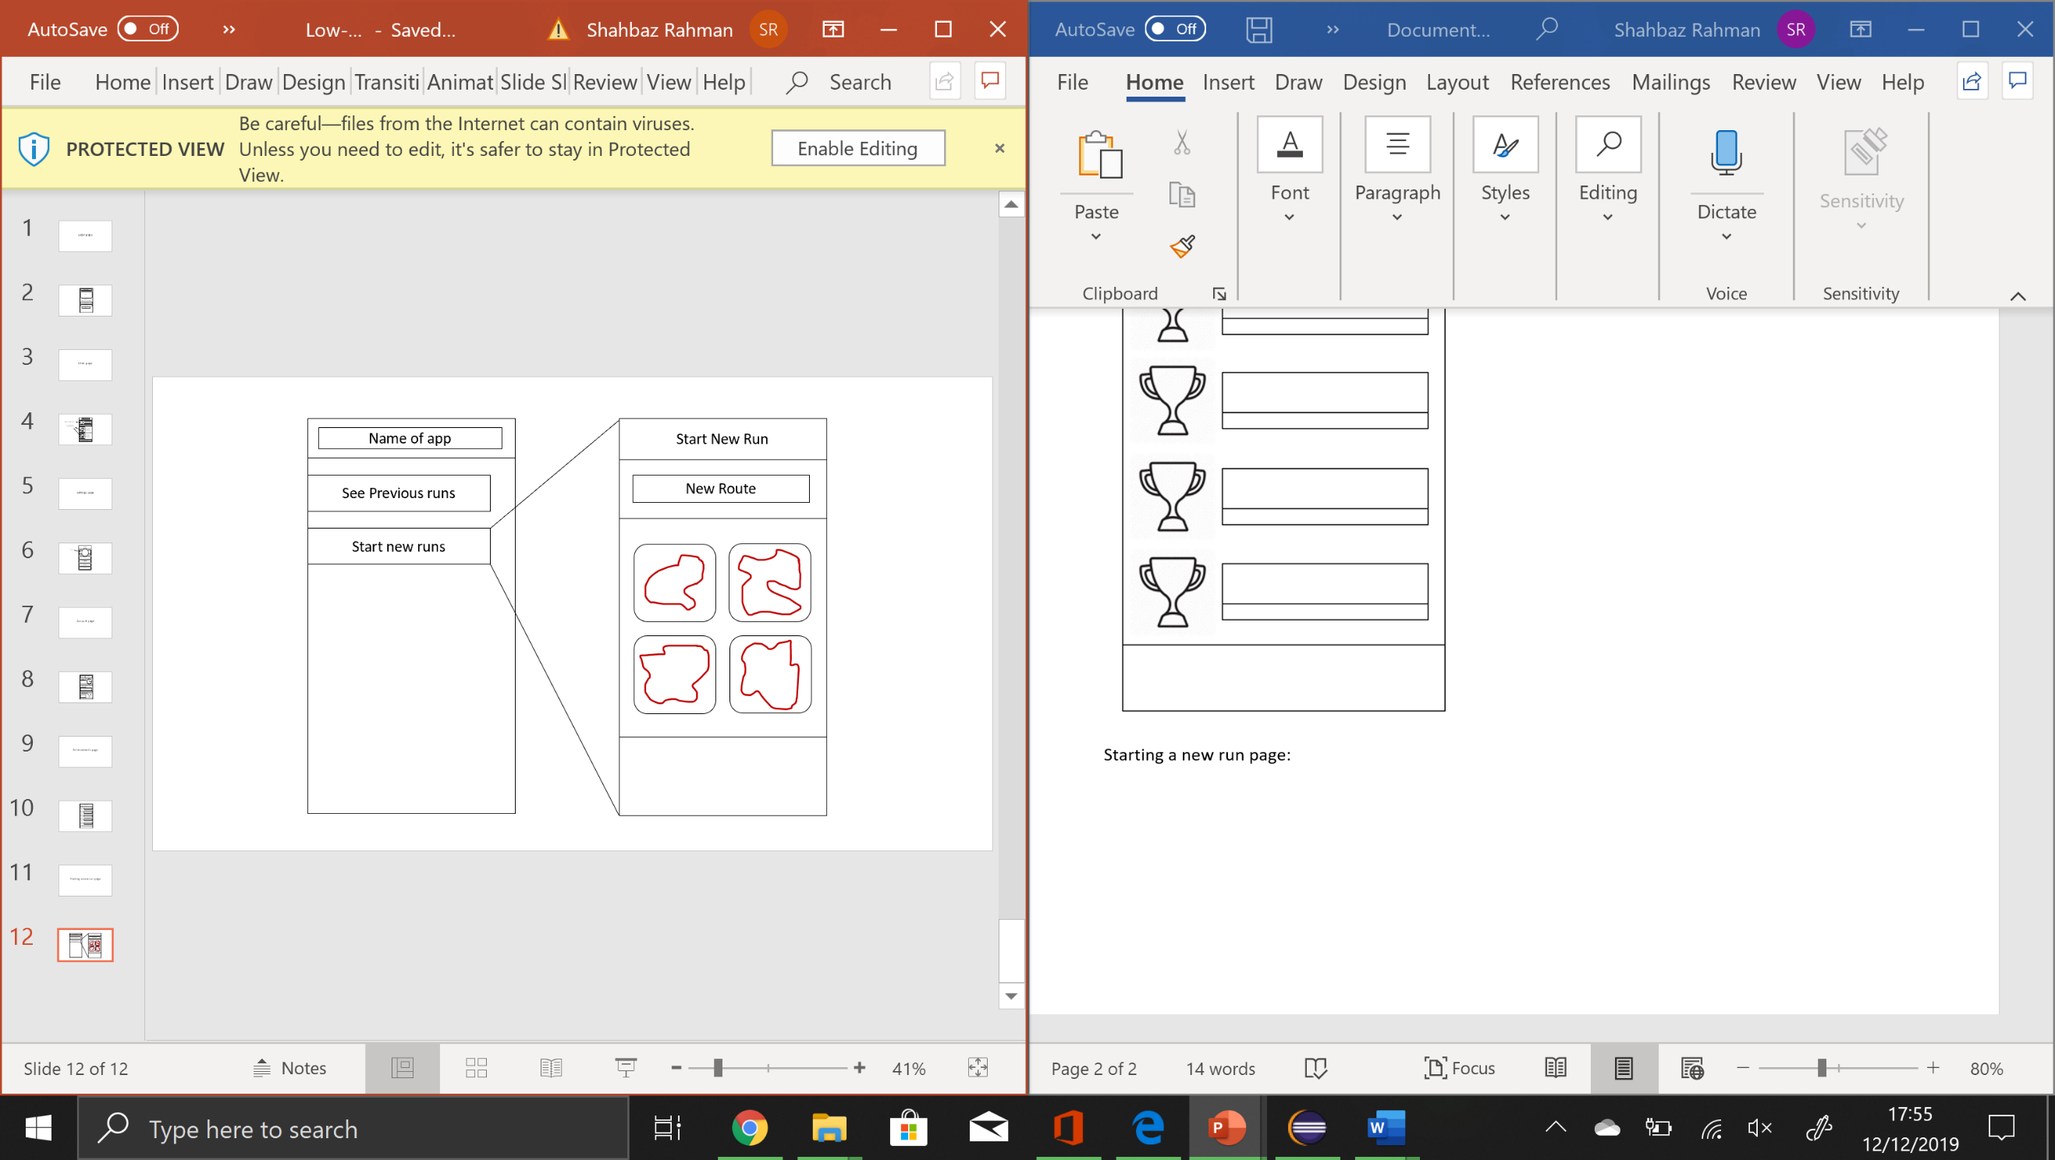 Achievements page: Starting a new run page:

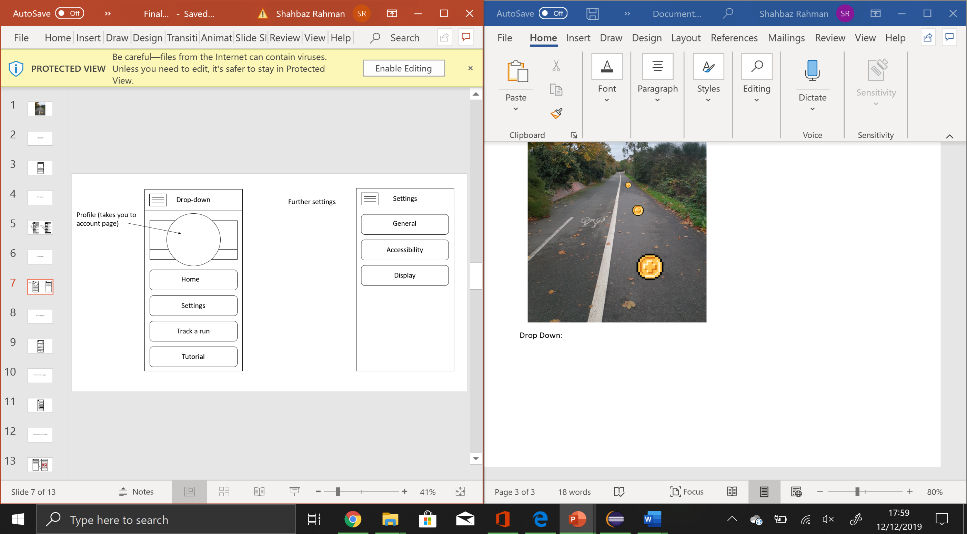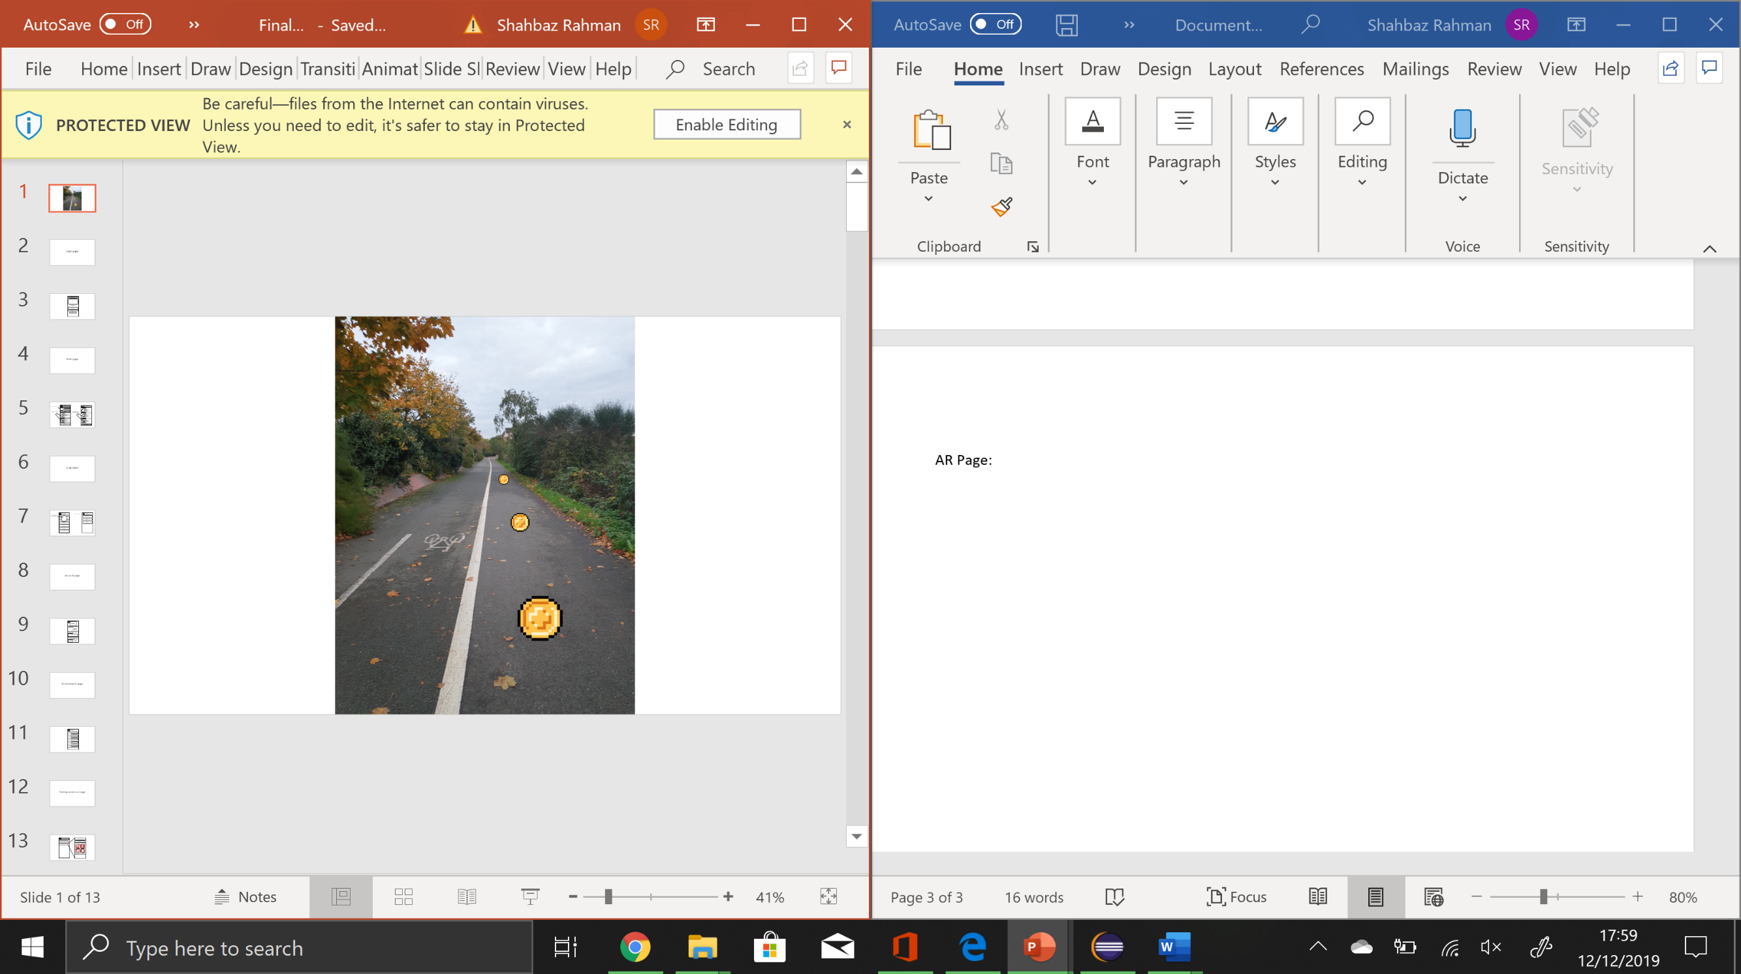 AR Page: Drop Down:

## Project management (Project Libre)

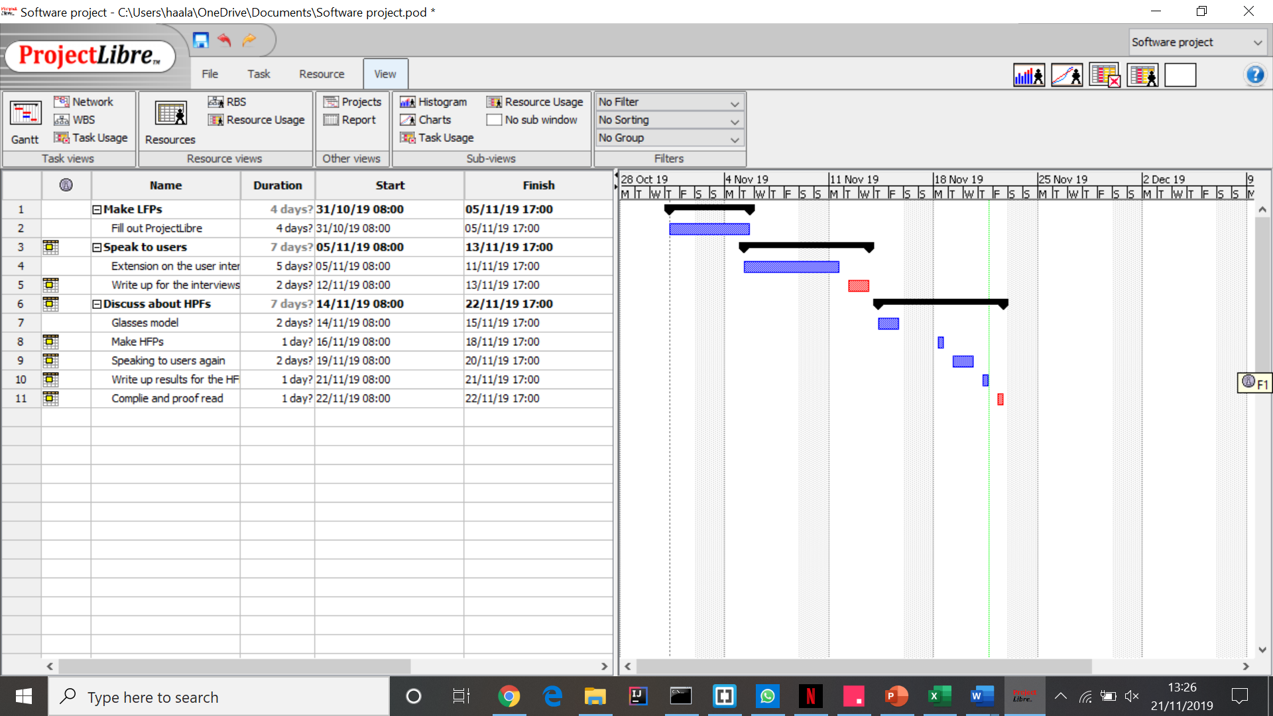

## Market Research Results (Collated data.xlsx)

**(Colour choices presented)**

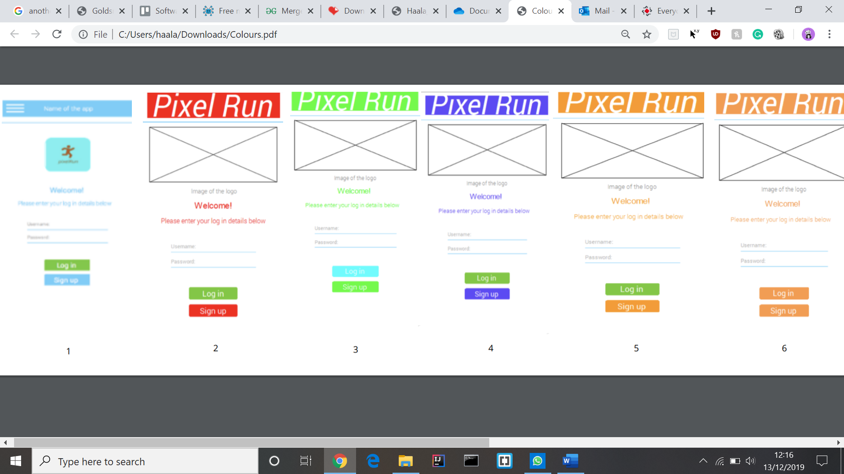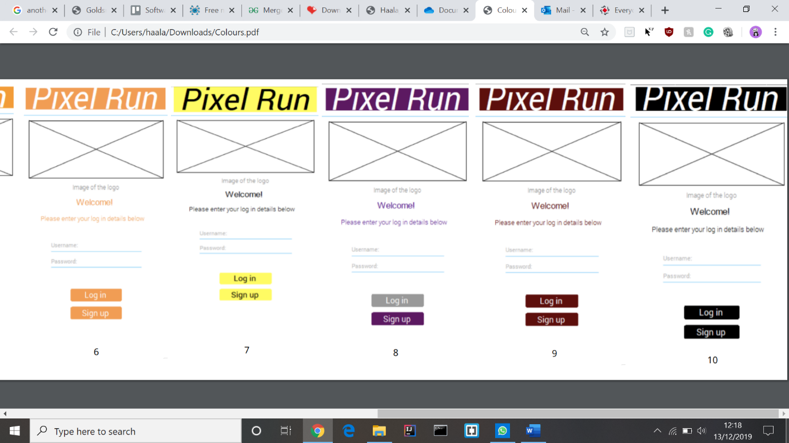

## Progress Log

|  |  |
| --- | --- |
| **Project Name** | *Pixel Run* |
| **Concept** | A turn-based VR story game. It will be a questioned based quiz game (maybe fitness, education, brain-stretching) and use “battles” with “monsters” as the way to learn. The user will select a timed option from a multiple-choice quiz to try and defeat the monsters. When you kill some “monsters” you will also be able to have trophies to say well done to the user for learning. The group is going to use Unity for this project. The group might also create 3D printed sculpture with QR codes, which are scannable (then the monsters can appear in the game). |
| **Project Number** | *Team 10* |
| **Document Start Date** | *Week 1 of Term 1* |
| **Business Plan Objective** | *Every project in a company or enterprise meets a business plan objective … Which part of a “your business” will this support, which business function will it support? Internal finance or admin? Product or service provided to customers? Human Resources? This will become clearer when your concept is defined* |
| **Sponsor/Supervisor** | **Abdelkrim Alfalah** |
| **Project Manager** | *Donald Duck* |

|  |  |  |
| --- | --- | --- |
| **Budget/hrs** |  | |
| Resource Name (Student Name) | | Budget/hrs |
| *BONAPARTE, Napolean* | | *300 – 40 (lectures) – 18 (labs) – 10 (supervisions) = 232 hrs. 30 weeks (including Christmas & Easter Vacations) so 11.54 hrs per week of which 7.33 hrs per week “non staff contact”* |
| *SKYWALKER, Luke* | | *232 hrs* |
| *DUCK, Donald* | | *232 hrs* |
| *BEEBLEBROX, Zaphod* | | *232 hrs* |
| *MAINWARING, Captain* | | *232 hrs* |
| *BRANSON, Richard* | | *232 hrs* |
| *Total hours:* | | *1392 hrs* |

**Objective/Scope**

* *Phase 1 of the project will encompass the following scope of achievements and outcomes. These individual achievements and outcomes meet the specific objectives for that phase. List the objectives, and the milestones for achieving the objectives.*
* *Phase 1 of the project will encompass the following scope of achievements and outcomes. These individual achievements and outcomes meet the specific objectives for that phase. List the objectives, and the milestones for achieving the objectives.*
* *Phase n of the project will encompass the following scope of achievements and outcomes. These individual achievements and outcomes meet the specific objectives for that phase. List the objectives, and the milestones for achieving the objectives.*

**Milestone Plan and Revision Plan**

|  |  |  |  |
| --- | --- | --- | --- |
| Milestone ID | Revision Plan, including budget revision | Milestone Date | Resources Required |
| *Each Milestone as an ID identity number.*  *Milestone 1* | *Record reasons for changes to the milestone plans* | *Date for the milestone to be delivered. Cross through and replace with new date if the plan changes.* | *Resources that you will need to commit to achieve this milestone.*  *Student 1: x hrs*  *:*  *Student n: y hrs*  *Cross through and enter new resource commitment details if the plan changes.* |
| Milestone 1 | N/A | 11/10/2019 | Student = 6  Hours = 2  2 * 6 = 12 hours  total hours left = 1380 |
| Milestone 2 | Had to do market research for 2 groups, meaning it took longer. | 18/10/2019 | 7.5 + 5 + 8 + 5 + 5.5 + 5.5 = 36.5 hours total  Total hours left =  1343.5 |
| Milestone 3 | Create UML diagrams for our project | 25/10/2019 | 5 + 5 + 7.5 + 4 + 5 + 0 = 22 hours total  1343.5 – 26.5 = 1317 total hours left |
| Milestone 4 | Creating a Project Libre timeline and starting working on the LFP (Low fidelity prototypes), organising what the group will do | 31/10/2019 | 2 + 2 + 2 + 2 + 2 = 10 hours total  1317 – 10 = 1307 total hours left |
| Milestone 4 | Making first iteration of LFP’s before the interviews. | *04/11/2019* | 0.5 + 0.5 + 0.5 + 0.5 = 2 hours total  1307 – 2 = 1305 total hours left |
| Milestone 4 | Conducting the 1st and 2nd iterations of the LFP interviews. | *05/11/2019* | 5.5 + 6.6 + 5.5 + 4.5 + 5.5 = 27.5 hours total  1305 – 27.5 = 1277.5 total hours left |
| Milestone 4 | Preparing the material so the final iteration of the interviews can be done. | *06/11/2019* | 1.5 + 1 = 2.5 total hours  1277.5 – 2.5 = 1275 total hours left |
| Milestone 4 | Conducting the final interviews and cleaning up the data. | *07/11/2019* | 2 + 1 + 1 + 1 = 5 total hours  1275 – 5 = 1270 total hours left |
| Milestone 4 | *Working on creating the HFP’s* | 14/11/2019 | 2 + 2 + 2 + 2 + 2 + 2 = 12 total hours  1270 – 12 = 1258 total hours left |
| Milestone 4 | *Finishing work on HFP’s* | 15/11/2019 | 1 + 1 + 1 + 1 + 1 = 5 total hours  1258 – 5 = 1253 total hours left |
| Milestone 4 | HFP interview’s | 16/11/2019 | 0.5 + 0.5 + 0.5 + 0.5 + 1 = 3 total hours  1253 -3 = 1250 total hours left |
| Milestone 4 | Collating all the data | 20/11/2019 | 2 total hours  1250 – 2 = 1248 total hours left |
| Milestone 4 | *Finishing submission for Milestone 4* | 21/11/2019 | 3 + 3 + 3 + 3 + 2 + 2 = 16 total hours  1248 – 16 = 1232 total hours left |
| Milestone 5 | *Working on Milestone 5* | 28/11/2019 | 3 + 3 + 3 + 3 + 3 + 3 = 18 total hours  1232 – 18 = 1214 total hours left |
| Milestone 5 and presentation | *Finishing Milestone 5 and starting the presentation preparation* | 04/12/2019 | 0.5 + 1 = 1.5 total hours  1214 – 1.5 = 1212.5 total hours left |
| Presentation and working on concept proposal | *Finishing the presentation preparation and starting work on the concept proposal* | 05/12/2019 | 3 + 3 + 3 + 3 + 3 + 3 = 18 total hours  1212.5 – 18 = 1194.5 total hours left |
| Working on the concept proposal | *Writing extra information for the concept proposal* | 06/12/2019 | 1 + 1 + 1 = 3 total hours  1194.5 – 3 = 1191.5 total hours left |
| Finishing the concept proposal and the Kanban backlog (Milestone 6) | *Finished the concept proposal (and printed), also completed filling the Kanban backlog* | 12/12/2019 | 6 + 6 + 7 + 6 + 6 + 1 = 32 total hours  1191.5 – 32 = 1159.5 total hours left |
| *Milestone n* | *Record reasons for changes to the milestone plans* | *Date for the milestone to be delivered. Cross through and replace with new date if the plan changes.* | *Resources that you will need to commit to achieve this milestone.*  *Student 1: x hrs*  *:*  *Student n: y hrs*  *Cross through and enter new resource commitment details if the plan changes.* |

**Status/Progress**

|  |  |  |  |
| --- | --- | --- | --- |
| **Date** | Task ID | Progress & Status | Resources Used: Name & hrs |
| *Date (perhaps once per week or other agreed reporting period, add a row for each example of what you have been busy with.* | *A specific task leading to an outcome/milestone The Task ID should point to the associated Milestone ID* | *What progress has been made on the task and therefore what is the status of that task and the associated outcome/milestone. This usually expressed as a percentage of completion. Does the Milestone plan need to change?* | *Student 1: x hrs*  *:*  *Student n: y hrs* |
| *Completing Milestone 1*  10/10/2019 | *Milestone 1* | *The group has completed Milestone 1, and successfully discussed and chose a concept which the group is all in agreement with.* | *All 6 students used 2 hrs each leaving 230 hrs left for each student or 1380 total hours left for the group.* |
| Completing Milestone 2  18/10/2019 | Milestone 2 | Completed market research and some 3D inductions. | 7.5 + 5 + 8 + 5 + 5.5 + 5.5 = 36.5 hours total  Total hours left =  1343.5 |
| Completing Milestone 3  24/10/2019 | Milestone 3 | Completed 5 UML diagrams for the milestone submission. | 5 + 5 + 7.5 + 4 + 5 + 0 = 22 hours total  1343.5 – 26.5 = 1317 total hours left |
| Starting work on Milestone 4  31/10/2019 | Milestone 4 | Creating a Project Libre timeline and starting working on the LFP (Low fidelity prototypes), organising what the group will do. | 2 + 2 + 2 + 2 + 2 = 10 hours total  1317 – 10 = 1307 total hours left |
| Preparation for milestone 4 interviews  *04/11/2019* | Milestone 4 | Making first iteration of LFP’s before the interviews. | 0.5 + 0.5 + 0.5 + 0.5 = 2 hours total  1307 – 2 = 1305 total hours left |
| Interviews for milestone 4  *05/11/2019* | Milestone 4 | Conducting the 1st and 2nd iterations of the LFP interviews. | 5.5 + 6.6 + 5.5 + 4.5 + 5.5 = 27.5 hours total  1305 – 27.5 = 1277.5 total hours left |
| Prep for final interviews  *06/11/2019* | Milestone 4 | Preparing the material so the final iteration of the interviews can be done. | 1.5 + 1 = 2.5 total hours  1277.5 – 2.5 = 1275 total hours left |
| Final interview for LFP’s  *07/11/2019* | Milestone 4 | Conducting the final interviews and cleaning up the data. | 2 + 1 + 1 + 1 = 5 total hours  1275 – 5 = 1270 total hours left |
| Stated work on HFP  14/11/2019 | Milestone 4 | *Working on creating the HFP’s* | 2 + 2 + 2 + 2 + 2 + 2 = 12 total hours  1270 – 12 = 1258 total hours left |
| HFP’s finished and can start interviews  15/11/2019 | Milestone 4 | *Finishing work on HFP’s* | 1 + 1 + 1 + 1 + 1 = 5 total hours  1258 – 5 = 1253 total hours left |
| Interviews finished  16/11/2019 | Milestone 4 | HFP interview’s | 0.5 + 0.5 + 0.5 + 0.5 + 1 = 3 total hours  1253 -3 = 1250 total hours left |
| Data all checked  20/11/2019 | Milestone 4 | Collating all the data | 2 total hours  1250 – 2 = 1248 total hours left |
| Finishing milestone 4 submission  21/11/2019 | Milestone 4 | *Finishing submission for Milestone 4* | 3 + 3 + 3 + 3 + 2 + 2 = 16 total hours  1248 – 16 = 1232 total hours left |
| Starting Milestone 5  28/11/2019 | Milestone 5 | *Working on Milestone 5* | 3 + 3 + 3 + 3 + 3 + 3 = 18 total hours  1232 – 18 = 1214 total hours left |
| Finishing milestone 5 and starting presentation work  04/12/2019 | Milestone 5 and presentation | *Finishing Milestone 5 and starting the presentation preparation* | 0.5 + 1 = 1.5 total hours  1214 – 1.5 = 1212.5 total hours left |
| Starting the concept proposal and finishing presentation work  05/12/2019 | Presentation and working on concept proposal | *Finishing the presentation preparation and starting work on the concept proposal* | 3 + 3 + 3 + 3 + 3 + 3 = 18 total hours  1212.5 – 18 = 1194.5 total hours left |
| Working on the concept proposal  06/12/2019 | *Writing extra information for the concept proposal* | *The group added more sections to the project proposal and fixed a few errors (such as using the word ‘we’ in the log)* | 1 + 1 + 1 = 3 total hours  1194.5 – 3 = 1191.5 total hours left |
| *Finished the concept proposal (and printed), also completed filling the Kanban backlog*  12/12/2019 | Finishing the concept proposal and the Kanban backlog (Milestone 6) | *The group finished and submitted the concept proposal, and submitted Milestone 6 (Kanban backlog)* | 6 + 6 + 7 + 6 + 6 + 1 = 32 total hours  1191.5 – 32 = 1159.5 total hours left |

|  |  |  |  |
| --- | --- | --- | --- |
| **Cumulative Resource Usage/hrs** | | | |
| Revision Date | Resource Name | hrs Used | hrs Remaining |
| *Start Date of Project* | *Student 1 = BONAPARTE, Napolean* |  | *232* |
| *10/10/2019* | *Student 1* | *a1 hrs = 2* | *232 - a1 = 230* |
| *17/10/2019* | *(4.5 hours meeting with team and working on milestone, 1 hour market research, excel file for the features 2 hours).* | *b1 hrs* | *232 - a1 - b1 = 222.5* |
| 24/10/2019 | *(5 hours of working on UML and finishing the sheets/diagrams)* | *:* | *222.5 – 5 = 217.5* |
| *31/10/2019* | *Working on Project Libre and assigning tasks about producing the LFP (step 1) before the user input.* | *:* | *217.5 – 2 = 215.5* |
| *14/11/2019* | *Working on creating the HFP’s (2 hours)* |  | *215.5 – 2 = 213.5* |
| *15/112019* | *Finishing work on HFP’s (1 hour)* |  | *213.5 – 1 = 212.5* |
| *16/11/2019* | *HFP interviews (1 hour)* |  | *212.5 – 1 = 211.5* |
| *21/11/2019* | *Finishing submission for Milestone 4 (3 hours)* |  | *211.5 – 3 = 208.5* |
| *28/11/2019* | *Worked on Milestone 5 (3 hours)* |  | *208.5 – 3 = 205.5* |
| *04/12/2019* | *Worked on Presentation (30 min)* |  | *205.5 – 0.5 = 205* |
| *05/12/2019* | *Worked on presentation and working on the concept proposal submission (3 hours)* |  | *205 – 3 = 202* |
| *06/12/2019* | *Worked on concept proposal submission (1 hour)* |  | *202 – 1 = 201* |
| *12/12/2019* | *Finished the concept proposal submission (6 hours)* |  | *201 – 6 = 195* |
| *End Date of Project* | *Student 1* | *z1 (26 weeks) hrs* | *232 - a1 - b1 … - z1 = 0 hrs* |
| *Start Date of Project* | *Student 2 = SKYWALKER, Luke* |  | *232* |
| *10/10/2019* | *Student 2* | *a2 hrs = 2* | *232 – a2 =230* |
| *17/10/2019* | *Student 2 (4.5 hours meeting with team and working on milestone, 30 min market research)* | *b2 hrs* | *232 – a2 – b2 = 225* |
| 24/10/2019 | Could not make it due to having the flu. | *:* | 225 – 0 = 225 |
| *31/10/2019* | *Working on Project Libre and assigning tasks about producing the LFP (step 1) before the user input.* | *:* | 225 – 2 = 223 |
| *04/11/2019* | *Made LFP drawings.* |  | 223 – 0.5 = 222.5 |
| *05/11/2019* | *Working on the LFP and doing market research (to see which designs to use and which individuals would be interested, also which path to go down for our project).* |  | 222.5 – 5.5 = 217 |
| *14/11/2019* | *Working on creating the HFP’s (2 hours)* |  | 217 – 2 = 215 |
| *15/112019* | *Finishing work on HFP’s (1 hour)* |  | 215 – 1 = 214 |
| *16/11/2019* | *HFP interviews (30 min)* |  | 214 – 0.5 = 213.5 |
| *21/11/2019* | *Finishing submission for Milestone 4 (3 hours)* |  | 213.5 – 3 = 210.5 |
| *28/11/2019* | *Worked on Milestone 5 (3 hours)* |  | 210.5 – 3 = 207.5 |
| *05/12/2019* | *Worked on presentation and working on the concept proposal submission (3 hours)* |  | 207.5 – 3 = 204.5 |
| *12/12/2019* | *Finished the concept proposal submission (6 hours)* |  | 204.5 – 6 = 198.5 |
| *End Date of Project* | *Student 2* | *z2 (26 weeks) hrs* | *232 – a2 – b2 … - z2 = 0 hrs* |
| *:* | *:* | *:* | *:* |
| *Start Date of Project* | *Student 3 = DUCK, Donald* |  | *232* |
| *10/10/2019* | *Student 3* | *a2 hrs = 2* | *232 – a2 =230* |
| *17/10/2019* | *Student 3 (4 .5hours meeting with team and working on milestones, 1 hour market research, 2.5 hours 3D printing induction and preparation)* | *b2 hrs = 7.5* | *232 – a2 – b2 = 222* |
| 24/10/2019 | *(5.5 hours of working on UML and finishing the sheets/diagrams, and 2 hours for the laser cutter induction)* | *:* | *222 – 7.5 = 214.5* |
| *31/10/2019* | *Working on Project Libre and assigning tasks about producing the LFP (step 1) before the user input.* | *:* | *214.5 – 2 = 212.5* |
| *04/11/2019* | *Made LFP power-point for AR element.* |  | *212.5 – 0.5 = 212* |
| *05/11/2019* | *Spent time getting the questions ready for interview 1 and working on slides. Working on the LFP and doing market research (to see which designs to use and which individuals would be interested, also which path to go down for our project).* |  | *212 – 6.5 = 205.5* |
| *06/11/2019* | *Spent time collating data on excel and charting the data, then some time helping Captain finish the last designs for the LFP.* |  | *205.5 – 1.5 = 204* |
| *07/11/2019* | *Finished last set of interviews for our LFP meaning this stage is finished and the group can move on to the HFP. Also collated all the data collected on excel and made a graph for the total market research.* |  | *204 – 2 =*  *202* |
| *14/11/2019* | *Working on creating the HFP’s (2 hours)* |  | *202 – 2 = 200* |
| *15/112019* | *Finishing work on HFP’s (1 hour)* |  | *22 – 1 = 199* |
| *20/11/2019* | *Collating all the data collected in the HFP interview’s (2 hours)* |  | *199 – 2 = 197* |
| *21/11/2019* | *Finishing submission for Milestone 4 (3 hours)* |  | *197 – 3 = 194* |
| *28/11/2019* | *Worked on Milestone 5 (3 hours)* |  | *194 – 3 =191* |
| *04/12/2019* | *Finished the M5 Milestone (1 hour)* |  | *191 – 1 = 190* |
| *05/12/2019* | *Worked on presentation and working on the concept proposal submission (3 hours)* |  | *190 – 3 = 187* |
| *06/12/2019* | *Worked on concept proposal submission (1 hour)* |  | *187 – 1 = 186* |
| *12/12/2019* | *Finished the concept proposal submission and finished the Kanban backlog (7 hours)* |  | *186 – 7 = 179* |
| *End Date of Project* | *Student 3* | *z2 (26 weeks) hrs* | *232 – a2 – b2 … - z2 = 0 hrs* |
| *:* | *:* | *:* | *:* |
| *Start Date of Project* | *Student 4 = BEEBLEBROX, Zaphod* |  | *232* |
| *10/10/2019* | *Student 4* | *a2 hrs = 2* | *232 – a2 =230* |
| *17/10/2019.* | *Student 4 (4.5 hours meeting with team and working on milestones, 30 min market research)* | *b2 hrs* | *232 – a2 – b2 =*  *225* |
| 24/10/2019 | *(4 hours of working on UML and finishing the sheets/diagrams)* | *:* | *225 – 4 = 221* |
| *31/10/2019* | *Not Present.* | *:* | *221 – 0 = 221* |
| *05/11/2019* | *Working on the LFP and doing market research (to see which designs to use and which individuals would be interested, also which path to go down for our project).* |  | *221 – 4.5 =216.5* |
| *07/11/2019* | *Finished last set of interviews for our LFP meaning this stage is finished and the group can move on to the HFP.* |  | *216.5 – 1 = 215.5* |
| *14/11/2019* | *Working on creating the HFP’s (2 hours)* |  | *215.5 – 2 = 213.5* |
| *16/11/2019* | *HFP interviews (30 min)* |  | *213.5 – 0.5 = 213* |
| *21/11/2019* | *Finishing submission for Milestone 4 (2 hours)* |  | *213 – 2 = 211* |
| *28/11/2019* | *Worked on Milestone 5 (3 hours)* |  | *211 – 3 = 208* |
| *05/12/2019* | *Worked on presentation and working on the concept proposal submission (3 hours)* |  | *208 – 3 = 205* |
| *06/12/2019* | *Worked on concept proposal submission (1 hour)* |  | *205 – 1 = 204* |
| *12/12/2019* | *Helped finish the concept proposal submission online (1 hour)* |  | *204 – 1 = 203* |
| *End Date of Project* | *Student 4* | *z2 (26 weeks) hrs* | *232 – a2 – b2 … - z2 = 0 hrs* |
| *:* | *:* | *:* | *:* |
| *Start Date of Project* | *Student 5 = MAINWARING, Captain* |  | *232* |
| *10/10/2019* | *Student 5* | *a2 hrs = 2* | *232 – a2 =230* |
| *17/10/2019.* | *(4.5 hours meeting with team and working on milestone, 1 hour market research)* | *b2 hrs* | *232 – a2 – b2 =*  *224.5* |
| 24/10/2019 | *(5 hours of working on UML and finishing the sheets/diagrams)* | *:* | *224.5 – 5 = 219.5* |
| *31/10/2019* | *Working on Project Libre and assigning tasks about producing the LFP (step 1) before the user input.* | *:* | *219.5 – 2 = 217.5* |
| *04/11/2019* | *Made LFP drawings.* |  | *217.5 – 0.5 = 217* |
| *05/11/2019* | *Working on the LFP and doing market research (to see which designs to use and which individuals would be interested, also which path to go down for our project).* |  | *217 – 5.5 = 211.5* |
| *06/11/2019* | *Finished off some interviews for the second LFP interview and spent time finishing the last iteration of LFP sketches on power-point.* |  | *211.5 – 1 = 210.5* |
| *07/11/2019* | *Finished last set of interviews for our LFP meaning this stage is finished and the group can move on to the HFP.* |  | *210.5 – 1 = 209.5* |
| *14/11/2019* | *Working on creating the HFP’s (2 hours)* |  | *209.5 – 2 = 207.5* |
| *15/112019* | *Finishing work on HFP’s (1 hour)* |  | *207.5 – 1 = 206.5* |
| *16/11/2019* | *HFP interviews (30 min)* |  | *206.5 – 0.5 = 206* |
| *21/11/2019* | *Finishing submission for Milestone 4 (3 hours)* |  | *206 -3 = 203* |
| *28/11/2019* | *Worked on Milestone 5 (3 hours)* |  | *203 – 3 = 200* |
| *05/12/2019* | *Worked on presentation and working on the concept proposal submission (3 hours)* |  | *200 – 3 = 197* |
| *12/12/2019* | *Finished the concept proposal submission (6 hours)* |  | *197 – 6 =191* |
| *End Date of Project* | *Student 5* | *z2 (26 weeks) hrs* | *232 – a2 – b2 … - z2 = 0 hrs* |
| *:* | *:* | *:* | *:* |
| *Start Date of Project* | *Student 6 = BRANSON, Richard* |  | *232* |
| *10/10/2019* | *Student 6* | *a2 hrs = 2* | *232 – a2 =230* |
| *17/10/2019* | *Student 6 = (4.5 hours meeting with team and working on milestones, 30 min Unity videos, 30 min market research)* | *b2 hrs* | *232 – a2 – b2 =*  *224.5* |
| 24/10/2019 | *(5 hours of working on UML and finishing the sheets/diagrams)* | *:* | *224.5 – 5 = 219.5* |
| *31/10/2019* | *Working on Project Libre and assigning tasks about producing the LFP (step 1) before the user input.* | *:* | *219.5 – 2 = 217.5* |
| *04/11/2019* | *Made LFP drawings.* |  | *217.5 – 0.5 = 217* |
| *05/11/2019* | *Working on the LFP and doing market research (to see which designs to use and which individuals would be interested, also which path to go down for our project).* |  | *217 – 5.5 = 211.5* |
| *07/11/2019* | *Finished last set of interviews for our LFP meaning this stage is finished and the group can move on to the HFP.* |  | *211.5 – 1 = 210.5* |
| *14/11/2019* | *Working on creating the HFP’s (2 hours)* |  | *210.5 – 2 = 208.5* |
| *15/112019* | *Finishing work on HFP’s (1 hour)* |  | *208.5 – 1 =207.5* |
| *16/11/2019* | *HFP interviews (30 min)* |  | *207.5 – 0.5 = 207* |
| *21/11/2019* | *Finishing submission for Milestone 4 (2 hours)* |  | *207 – 2 = 205* |
| *28/11/2019* | *Worked on Milestone 5 (3 hours)* |  | *205 – 3 = 202* |
| *05/12/2019* | *Worked on presentation and working on the concept proposal submission (3 hours)* |  | *202 – 3 = 199* |
| *12/12/2019* | *Finished the concept proposal submission (6 hours)* |  | *199 – 6 =193* |
| *End Date of Project* | *Student 6* | *z2 (26 weeks) hrs* | *232 – a2 – b2 … - z2 = 0 hrs* |
| *:* | *:* | *:* | *:* |
| *Start Date of Project* | *Student n* |  | *232* |
| *Date (perhaps once per week or other agreed reporting period, add a row for each student and their total busyness.* | *Student n* | *an hrs* | *232 – an =* |
| *Date (perhaps once per week or other agreed reporting period, add a row for each example of what you have been busy with.* | *Student n* | *bn hrs* | *232 – an – bn =* |
| *:* | *:* | *:* | *:* |
| *:* | *:* | *:* | *:* |
| *End Date of Project* | *Student n* | *zn (26 weeks) hrs* | *232 – an – bn … - zn = 0 hrs* |